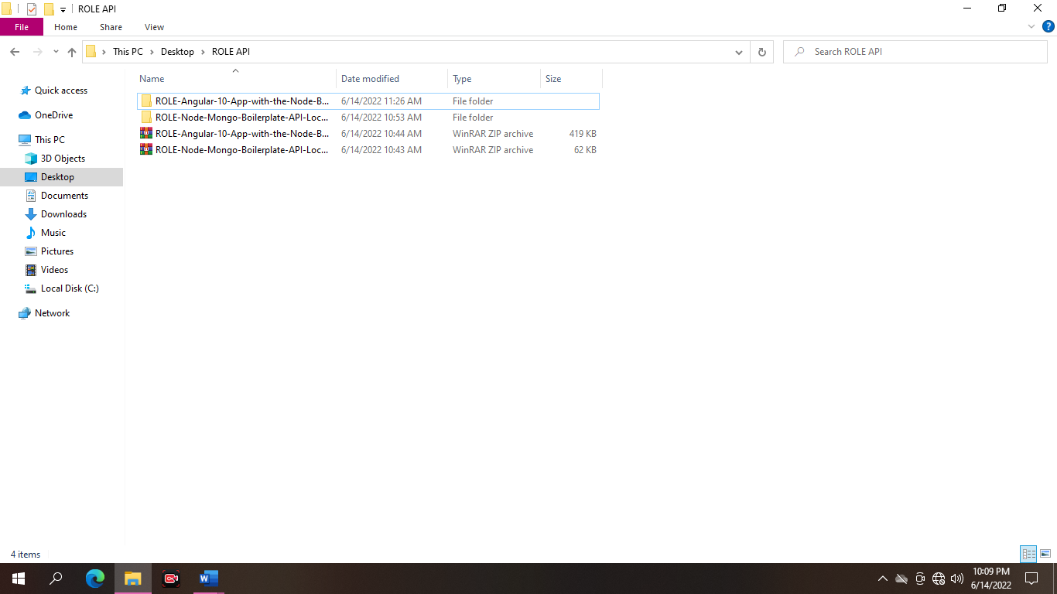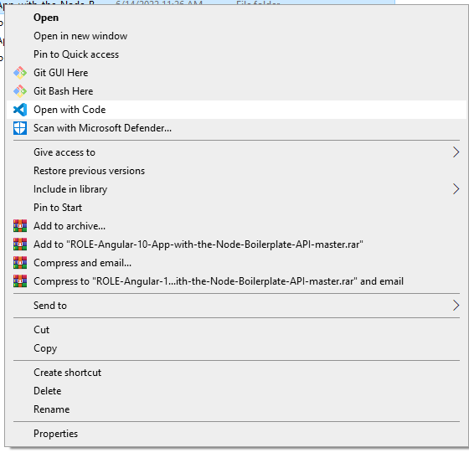**User Management with Role**

First, you may right click, you can see open with code then open.

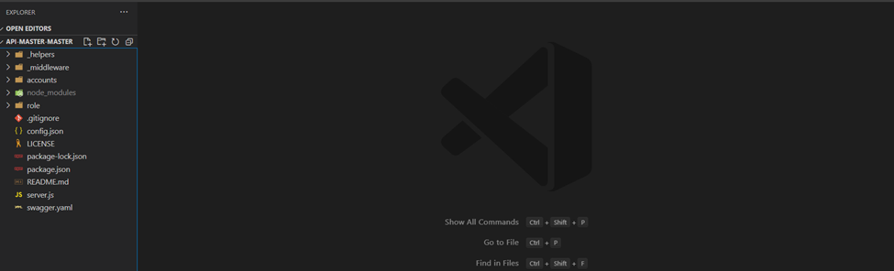

You can see below with empty codes

**Now open new terminal.**



**Type “npm install or npm i” Wait until the installation in done.**

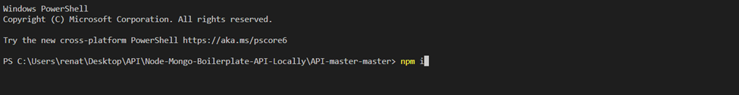

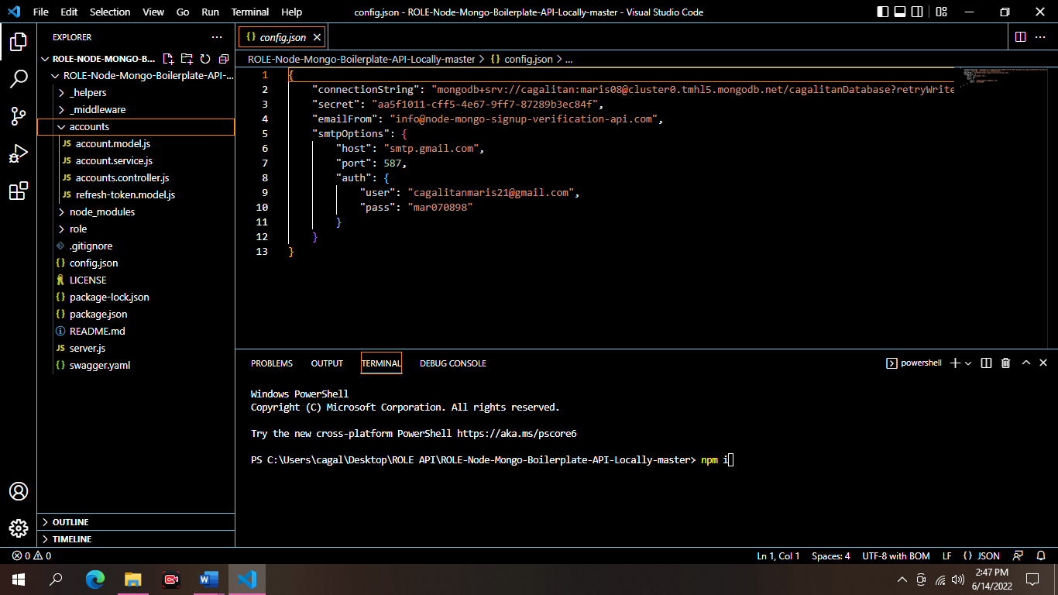

And rename the files to role.

After installing, Copy the account file

After that you can now change the controller, model and service code.

You can see below the screenshot.

role.controller.js

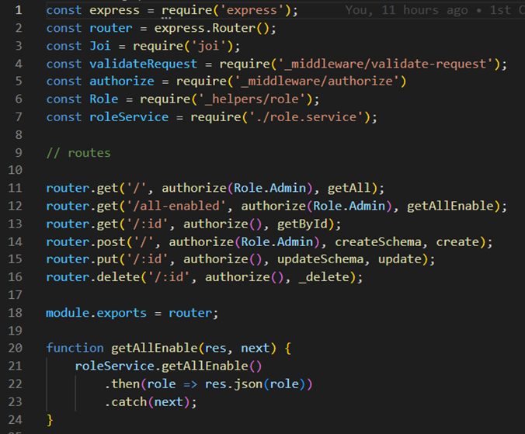

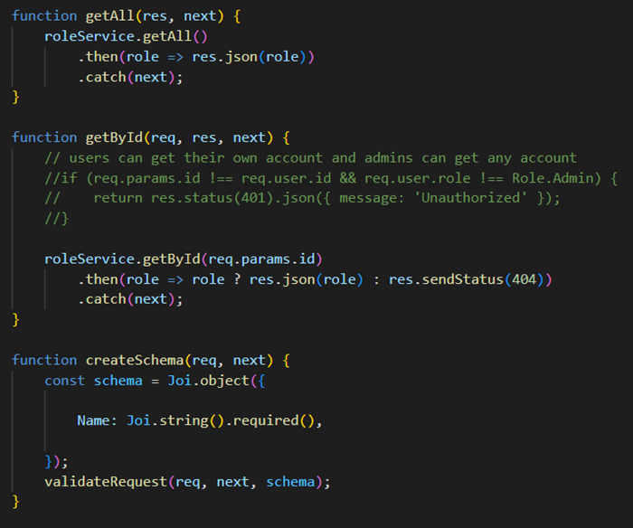

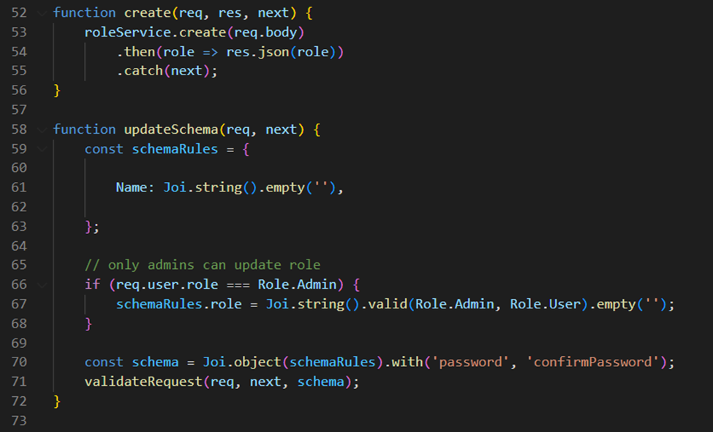

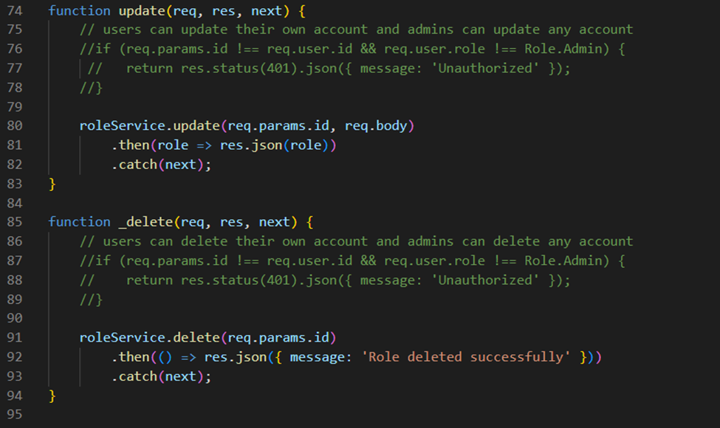

**role.model.js**

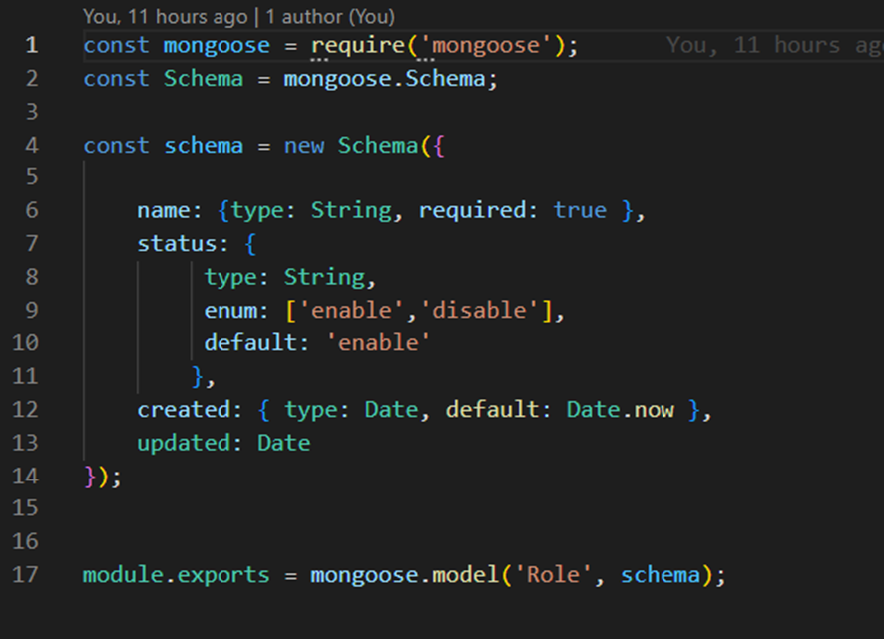

role.service.js

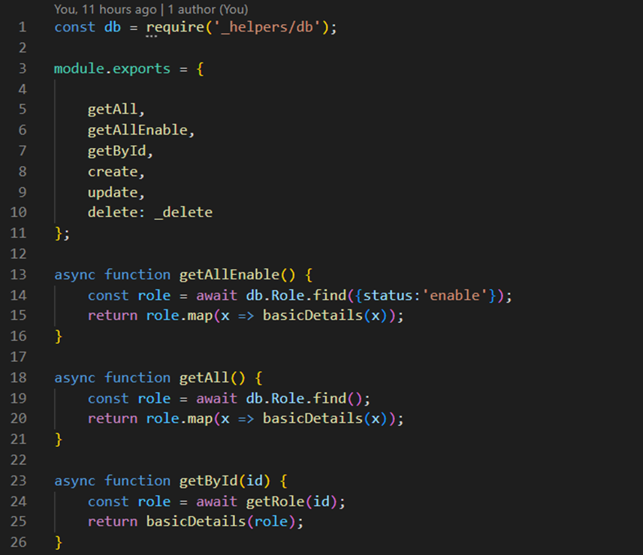

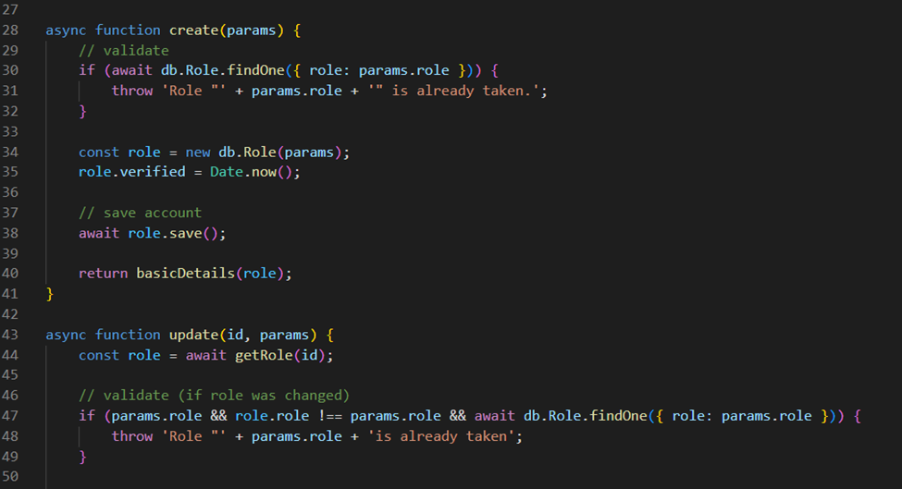

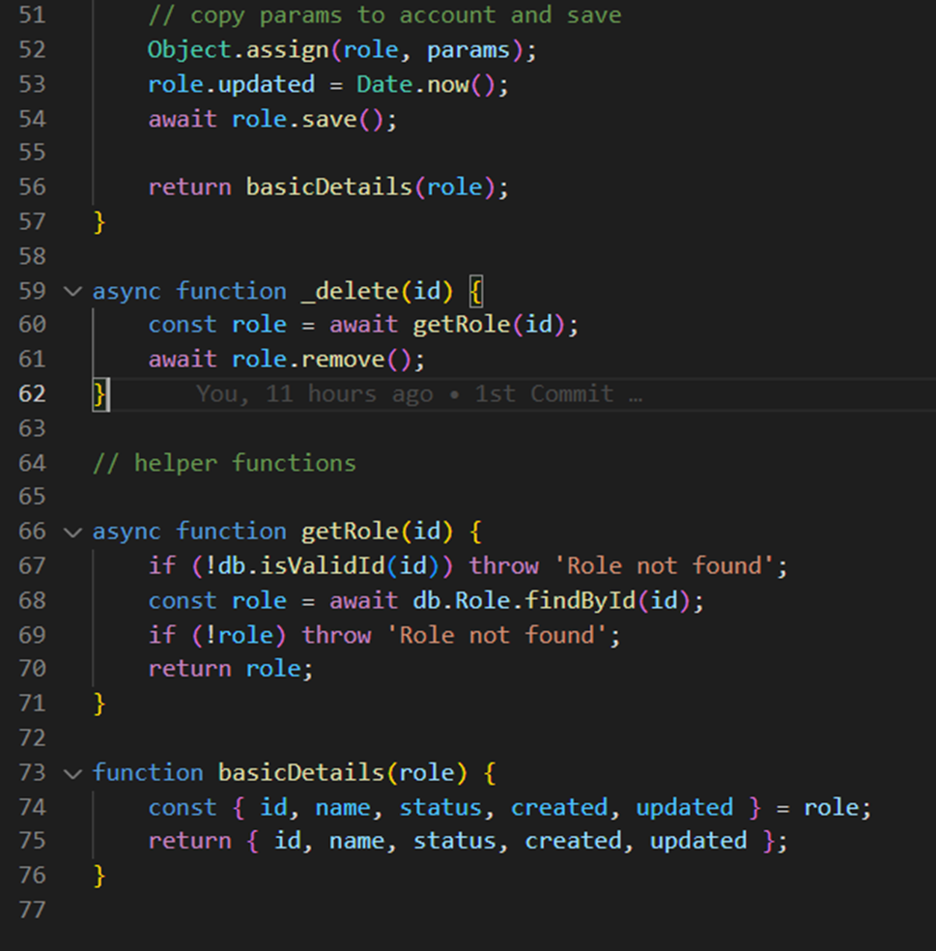

**After you edit the codes Don’t forget to edit the SERVER.JS**



**Angular-10-App-with-the-Node-Boilerplate-API-master**

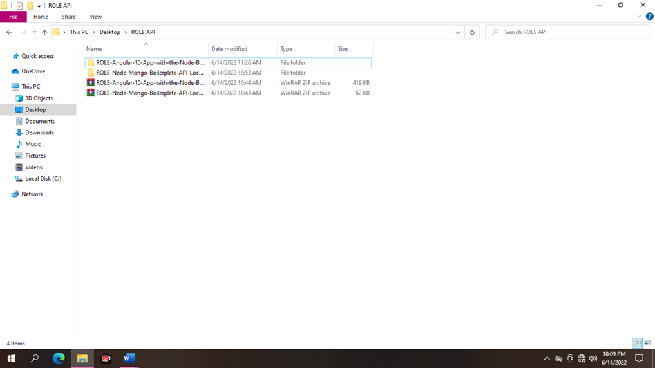

First, you may right click, you can see open with code then open.

**Go to scr/app and trace the routes.**

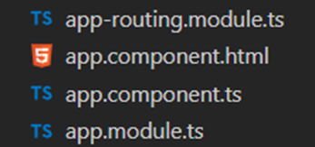

**Add to this code to ADMIN-ROUTING-MODULES.TS**



**You can edit the files and code, change the accounts or account to role or roles.**

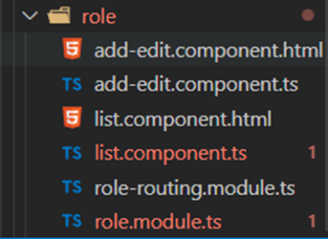

**role.module.ts**

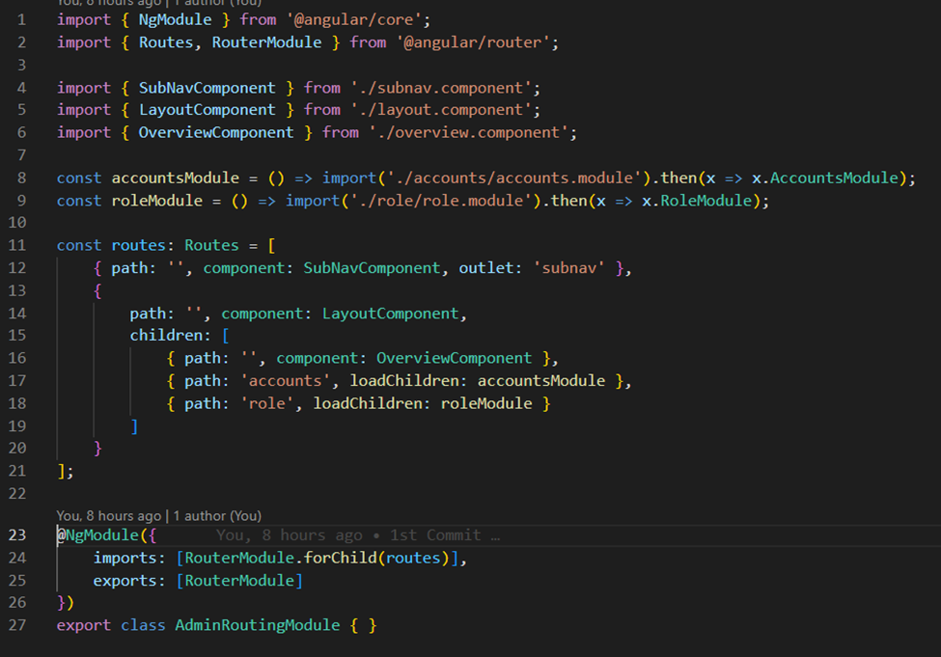

**Role.routing.module.ts**

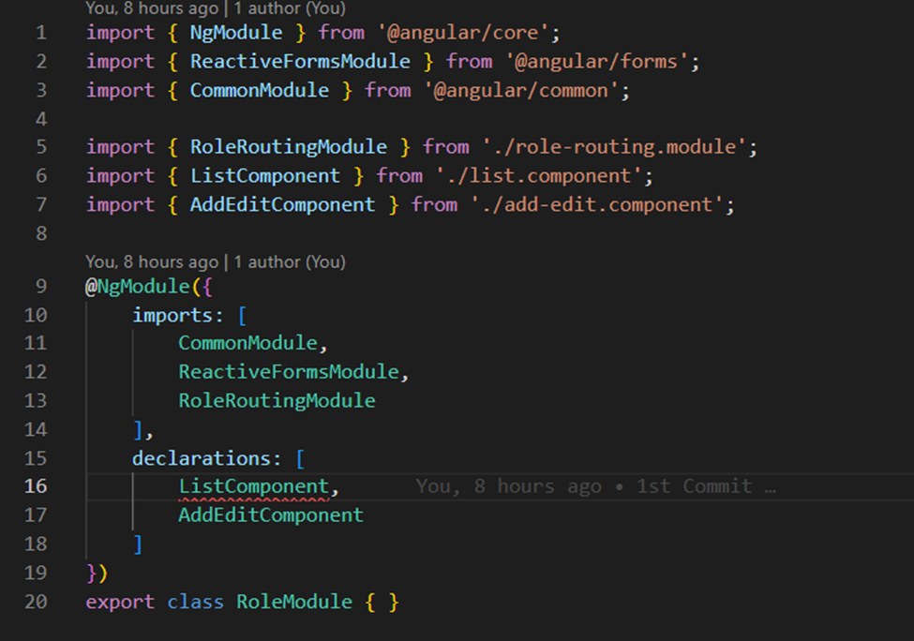

**list.component.ts**

